**WCS Project KT**

**Dev site url** :- https://wcs-dev.azurewebsites.net/  
**admin url** :- <https://wcs-dev.azurewebsites.net/wp-admin>  
**QA site url** :- https://wcs-qa.azurewebsites.net/  
**admin url** :- <https://wcs-qa.azurewebsites.net/wp-admin>  
  
**user** :- greenriver-wcs-administrator  
**password**:- greenriver-wcs-administrator@123

============================================================================  
**Dev FTP server details**-----------------------------  
URL:- <https://wcs-dev.azurewebsites.net>  
Ftp details:- ftps://waws-prod-dm1-043.ftp.azurewebsites.windows.net/site/wwwroot  
user name:- wcs-dev\$wcs-dev  
password:- qeA3NuwX9H1EzeuScnJ70tQZxE7P7wsmCGqDFd5AqYRxKQlqgJaRjsEpAjWf

==============================================================================  
**QA FTP server details**  
----------------------------   
FTP details:- ftps://waws-prod-dm1-043.ftp.azurewebsites.windows.net/site/wwwroot  
user name:- wcs-qa\$wcs-qa  
Password:- DAc8oB8SjDDflAytpYHMbvjjtydCtx6rGjbXHhBYJuhFr0etZDQ5ynB7zMC8

**Home page** :-

1. Main slider comes from revolution slider
2. After that part comes from **home-template-body-content.php** file.
3. In this image red mark, I have two separate code for dev and QA, because in dev env we different post ID and QA env have different post ID.  
   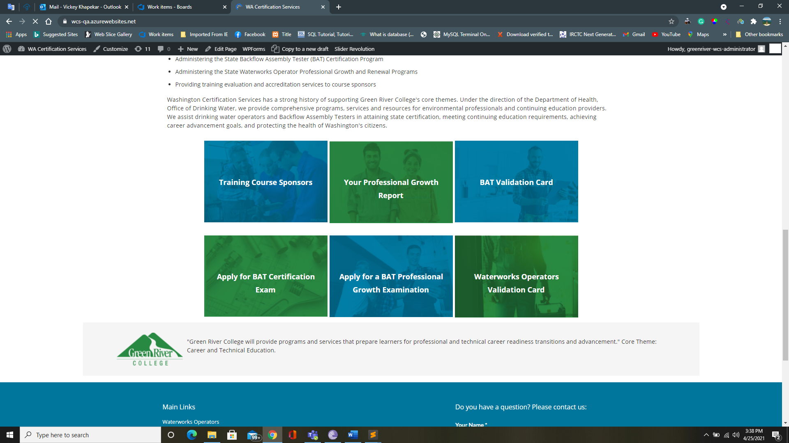

**Waterworks Operator Main page :-**

1. This page come from **page-waterworks-operators-mainpage.php** file and in this file have dynamic code.
2. For svg image, if you check svg image code, there is one <g> tag and inside the <g> tag have ID, so whenever you add new svg image icon for this purpose then you have to provide particular ID and same ID   
   Text

   Description automatically generated

And also we need to pass same ID in admin sideon respective page

1. For adding text or any other HTML code in admin side, you have to follow same flow as same as other pages we followed.

**Waterworks Operator Sub page :-**

1. This page come from **page-waterworks-operators-subpage.php** file and in this file have dynamic code.
2. For svg image and adding html code or text, follow WWO main page 2 and 3 point.
3. And creation new sub page check these image for steps  
   Graphical user interface, text, application

   Description automatically generated

And after followed these steps then add you data.

**Training Course Operators Main page:-**

1. This page come from **page-training-course-sponsors-mainpage.php** file and in this file have dynamic code.

**Training Course Operators Sub page:-**

1. This page come from **page-training-course-sponsors-subpage.php** file and in this file have dynamic code.

**Backflow Assembly Testers Main page:-**

1. This page comes from page-backflow-assembly-testers-mainpage.php file

**Backflow Assembly Testers Sub page:-**

1. This page comes from page-backflow-assembly-testers-subpage.php file

**Files for CSS and JS and php**

1. For css, all css code have in this path file :-  **bento-child/assets/css/cutom_styles/styles.css**
2. For js, all js code have in this path file :-  **bento-child/assets/js/custom.js**
3. I have added some JS code in footer file, like when click on footer **Back to Top** link then its scroll smoothly top of the head – this code works in js file but sometimes its not loading/working that why I have added in footer file.
4. And for when we click on anchor tag + hash-accordion value then it will redirect to the respective page and open respective accordion – this js code works only main accordion not for sub-accordion if code added in JS file that’s why I have added in footer file.